Minutes
MEETING OF THE
BOARD OF DIRECTORS
Florida DKG Educational Foundation, Inc.

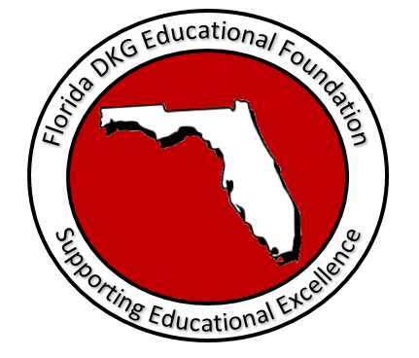

Orlando Marriott Lake Mary
Lake Mary, Florida

April 26, 2019

Meeting Minutes
Board of Directors

Florida DKG Educational Foundation

Orlando Marriott Lake Mary
Lake Mary, Florida
Date: April 26, 2019

Chair, Dr. Elsie Gross, called to order the meeting of the Board of Directors of the Florida DKG Educational Foundation, Inc. on Friday, April 26, 2019, at 3:05 p.m. at Orlando Marriott Lake Mary, Florida.  Members present were:  Dr. Elsie Gross, chair  Dr. Beverly Helms, vice chair  Nancy Bentz, secretary  Connie Kostyra, treasurer  Merle Jones  Carrie Frye  Dr. Kay Clawson  Ann Tikka  Dr. Constance Besco  Carol Ann Casey, state president  A quorum was present.  Special welcome to Dr. Kay Clawson and Dr. Connie Besco. | Call to Order
The minutes dated September 21, 2018, were approved and signed by Merle Jones and Carrie Frye. Dr. Elsie Gross appointed Dr. Kay Clawson and Connie Kostyra to review the April 26, 2019, minutes. | Approval of the Minutes and Appointment of Committee to Review Minutes
With changes to the names of certain committee members, the meeting’s agenda was approved with consensus. (See Attachment 1)  Dr. Gross reviewed the committee assignments. (See Attachment 2) The Directors’ Terms of Office were reviewed. (See Attachment 3) The Board of Directors’ roster was reviewed. (See Attachment 4) | Approval of the Agenda and Additional Handouts
With the assistance of our CPA, Judith Lenz, our Corporate Income Tax Filing for 2018 was filed on October 14, 2019.  The Annual Corporation Report to the Florida Department of State was filed on February 16, 2019. The certificate may be viewed on line at: sunbiz.org, Corporations.  Once today’s minutes are approved, the April 26, 2019, board meeting minutes will be posted on the website at fldkgef.org. These minutes will replace previous minutes. | Report of the Secretary
Kostyra distributed copies of the Trace of Cash dated July 1, 2018, through December 2018. (See Attachment 5)  The bank balance on March 31, 2019, was $135,990.16. The report was reviewed. Kostyra presented the financial audit completed by Diane Spence, our audit reviewer. Questions and discussion followed. Receipts and paperwork pertaining to this treasurer’s report are available upon request. | Report of the Treasurer
Committee Reports Related to Motions
Bentz welcomed Dr. Constance Besco to the committee. | Bylaws Committee  Nancy Bentz
Merle Jones reported on the committee’s plans for fundraising at the Fall Executive Board Meeting. Jones plans to ask chapter presidents to remind members to use AmazonSmile and designate the Foundation as its recipient for donations.  Jones suggested that since our original monies, $100,000.00, will not be used for grants, that it be listed separately on our financial reports. Decision was made that this money may be reported separately, but not listed separately on the Trace of Cash. Jones will research the state minutes to ensure restrictions and/or reporting on this money were not specified for reporting purposes.  The chapter contacts list was reviewed by Jones. There are still a small number of chapters that have not provided a contact for their chapter. For those that have not provided a name, a contact form will be placed at the chapter president’s place at the April 27, 2019, Executive Board Meeting/General Session.  Gross reported on letters of appreciation from donors. Dr. Beverly Helms agreed to help with the thank you letters. Gross reviewed the contributors’ page in the State Convention program. Carrie Frye suggested we put the list of contributors on a poster to set up during the Fall Convention. | Finance Committee  Merle Jones
This year’s award recipients are from District I and Certificates of Congratulations will be presented at the luncheon on April 27th. Our workshop set for April 27th will be to discuss an overview of the Foundation and to have a discussion with participants for more ideas, such as projects, to be awarded.  The professional development award application will be updated on September 1, 2019. If project grants will be included for the next award period, a form will be created. Clawson presented a variety of draft forms used in other states. | Grants and Awards Committee,  Dr. Beverly Helms, Chair
Bylaws state we can have up to 12 members, not less than 8. One opening may be filled. Our Foundation has two new members, so Board members agreed to leave the number of members at 11. | Nominations Committee, Merle Jones, Chair
Frye provided Helms with Foundation literature so it may be passed out to the April 27th workshop attendees.  The Educator Express will be published just three times a year instead of quarterly. Group agreed and the Express will be sent in late August/September 1, December 1, and April 1.  The new pamphlet was presented, group agreed that from year to year the front will change and the awardee names and information will be continuously updated.  Social media has made some progress, which may lead to more contributions. At this time, contributions are down by 16% compared to last year. Number of visitors on social media was up in March/April.  Group gave accolades to our webmaster, Debra Graff.  Ann Tikka has been contributing articles to the Florida Rays. | Public Relations Committee,  Carrie Frye, Chair
Unfinished Business
Gross pointed out that the Policies are stated in the Bylaws, therefore it is not necessary to include the policies in the proposed procedures manual. The procedures will describe how duties, as written in the Bylaws, are being accomplished. Included in the procedures will be the requirement to regularly share documents electronically with fellow committee members.  Our Foundation table at our events will be attended by a committee member at all times so we may communicate the deadlines, award and/or possible grants, application process and forms, collect contributions, discuss purposes, and pass out pamphlets. A contribution and award board will be included in the fall and placed on our foyer table. | Policies and Procedures  Dr. Elsie Gross  Information Table  Dr. Elsie Gross
New Business
All committee members will have jobs at the workshop, such as timekeepers and recording participants’ discussions and ideas. | Foundation Workshop
Gross expressed accolades and gratitude to all committee members. | Thoughts/  Comments
Meeting was adjourned at 4:55 p.m. | Adjournment

Florida DKG Educational Foundation, Inc.

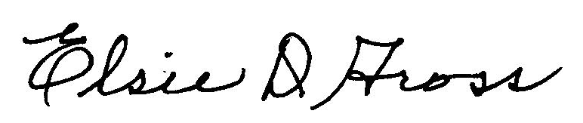

Dr. Elsie Gross
2019-22, Chair, Board of Directors
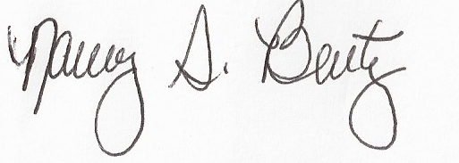
Nancy S. Bentz, Secretary

APPROVED:

COMMITTEE TO APPROVE MINUTES OF THE
EDUCATIONAL DKG EDUCATIONAL FOUNDATION, INC. Board of Directors

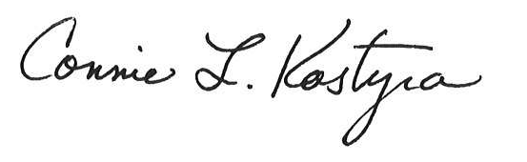
_________________________________________________
Connie Kostyra

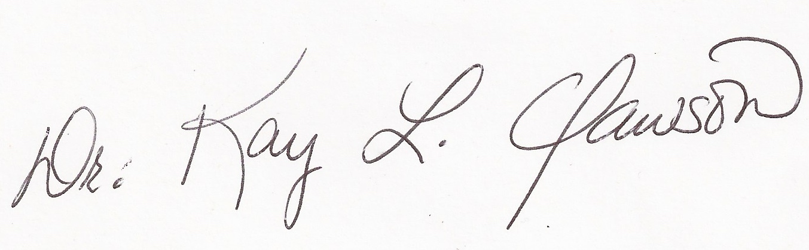
_______________________________________________
Dr. Kay Clawson

