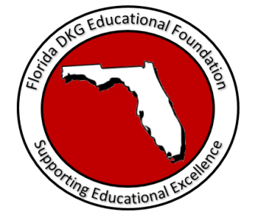
Florida DKG Educational Foundation
Information Sheet for Educational Grant
(Valid for funding April 1, 2021 – March 31, 2022)

What is the Florida DKG Educational Foundation?
The Florida DKG Educational Foundation is a non-profit, 501(c)(3) corporation that provides funding for activities that support professional and personal growth of women educators in the state of Florida, and promotes educational excellence for Florida students.
What is the Florida DKG Educational Grant?
The Educational Grant is available and may be used to cover costs associated with but not limited to the following examples: classroom activities, projects, materials, supplies, field trips, speakers, follow up activities to support previous professional development, limited equipment to support classroom activities and/or other activities designed by active or retired educators to implement in schools or communities. This grant is to promote educational excellence for Florida students. The maximum amount of the grant is $1,000. Funding is available for activities that occur between April 1, 2021, and March 31, 2022.

Who May Apply?
Any employed or retired Florida educator who designs and conducts an activity to support educational excellence in Florida. It is an individual and not a group award. An individual may receive only one Educational Grant. Notification of acceptance or non-acceptance will be made approximately six weeks following the deadline for receipt of application.

How will the grant be received? If an application is approved, applicants:
- May receive a grant for the full amount or only a portion of the amount requested;
- Will receive the full amount of the grant upon notification;
- Shall submit documentation of completion of the educational activity within fourteen (14) days after completion date;
- Shall return the grant funds if unable to implement the activity;
- May not transfer the grant funds.

What if I receive another grant/award for the same activity?
To avoid duplication of funding an applicant submitting an application to another funding source for the same educational activity stated in this application must inform the chair of the Florida DKG Educational Foundation if notified of receipt of funding from another source for the same activity.

(Continued on next page)

How do I submit the application?
Application Deadline: February 1 of each year. Applications will be considered only if submitted electronically on or before February 1. Submit by email the completed application with the required attachments to Awards.FLDKGEF@gmail.com. Upon submission, an email confirmation will be sent as proof of receipt of application.

If Funding is granted you are required to:
- Give recognition to the Florida DKG Educational Foundation for the funding
- Submit a personal photo for the Foundation’s publications
- Submit a year-end, or an end-of- activity report (within 14 days of the completion of the activity) with documentation of activity

Florida DKG Educational Foundation
Educational Grant Proposal
Scoring Rubric

(The rubric is included for the applicant’s information. Application will be scored using this rubric.)

Requirements
- Complies with laws governing tax-exempt Foundations
- Fulfills all deadline requirements
- Educator contact information is complete and listed
- Responds completely to all items. Marks NA if not applicable
- Applications not complete by the deadline will be disqualified.

- Proposal 20 points

  - Clear and complete description of activity
  - Explanation of how the activity promotes educational excellence

- Activity 50 points
  - Project activities are stated
  - Goals/Objectives are specific and measurable
  - Site at which activity will occur is stated
  - Need(s) is justified
  - Date the activity will be implemented is given

4. Anticipated Expenses 20 points
a. Anticipated costs are specific, itemized, and documented.
Documentation of cost must be included with application
b. Costs are comparable with planned activities

5. Quality of Application 10 points

TOTAL OUT OF POSSIBLE 100 ______________

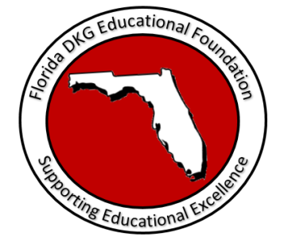

2021 Florida DKG Educational Foundation
Educational Grant Application
(This is a one page application. You may use additional space.)

The Educational Grant is available and may be used to cover costs associated with but not limited to the following examples: classroom activities, projects, materials, supplies, field trips, speakers, follow up activities to support previous professional development, limited equipment to support classroom activities and/or other activities designed by active or retired educators to implement in schools or communities. This award is to promote educational excellence for Florida students.
Educator requesting the funds:
- Name: Home Phone: Cell:
- Complete Mailing address:
- Email Address:
- Member of DKG? Chapter Name: Project Title:
Proposed Educational Activity :
Write a brief narrative including:
- General description of the educational activity

- Give a brief explanation of how the project will promote educational excellence for Florida students.
- Specific activities of the project

- Goals/ Objectives (Be specific and measurable)

- Site at which the activity will occur
- State justification of need for activity

- Date the activity will be implemented
Anticipated Expenses:
- Itemize all anticipated costs.
- Document all anticipated costs associated with the activity. (Be specific and attach documentation of costs with the application. Undocumented costs will not be funded.)
- List any funding assistance from other sources.
- Report total anticipated cost of activity (Less other funding sources).

Signature: ______________________________ Date Submitted: ____________________

